**Ex.no 9**

**Pl/sql procedure**

1. Write a sql procedure program to find the largest of given three numbers.( Hint: A,B,C as IN parameter and Large as OUT parameter)

SQL> declare

2 a number:=10;

3 b number:=12;

4 c number:=5;

5 begin

6 dbms_output.put_line('a='||a||' b='||b||' c='||c);

7 if a>b AND a>c

8 then

9 dbms_output.put_line('a is greatest');

10 else

11 if b>a AND b>c

12 then

13 dbms_output.put_line('b is greatest');

14 else

15 dbms_output.put_line('c is greatest');

16 end if;

17 end if;

18 end;

19 /

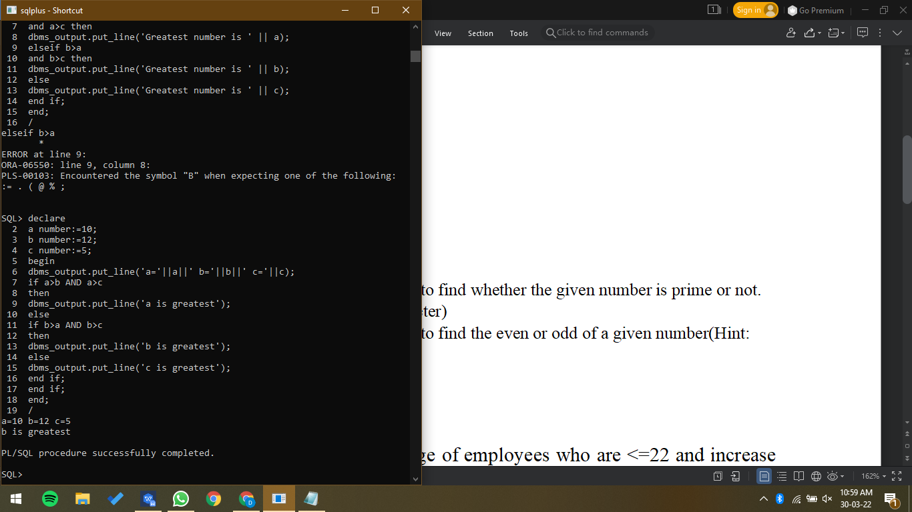

1. Write a sql procedure program to find whether the given number is prime or not. (Hint: use P as IN OUT parameter)

SQL> declare

2 n number;

3 i number;

4 flag number;

5

6 begin

7 i:=2;

8 flag:=1;

9 n:=&n;

10

11 for i in 2..n/2

12 loop

13 if mod(n,i)=0

14 then

15 flag:=0;

16 exit;

17 end if;

18 end loop;

19

20 if flag=1

21 then

22 dbms_output.put_line('prime');

23 else

24 dbms_output.put_line('not prime');

25 end if;

26 end;

27 /

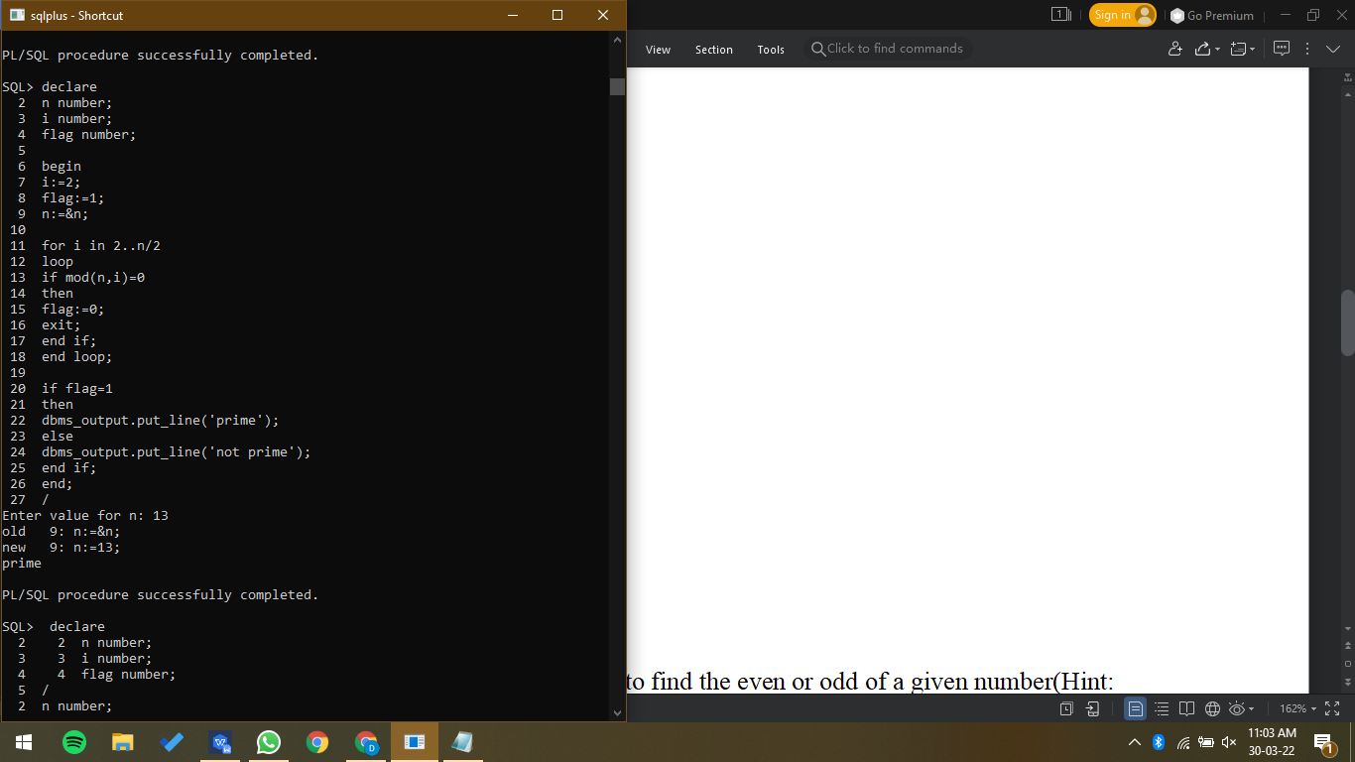

1. Write a sql procedure program to find the even or odd of a given number(Hint: Use A as IN OUT parameter)

SQL> declare

2 n number:=&n;

3 begin

4 if mod(n,2)=0

5 then

6 dbms_output.put_line('number is even');

7 else

8 dbms_output.put_line('number is odd');

9 end if;

10 end;

11 /

